**Wind Energy Conversion Systems**

**Assignment 2**

**Muhammad Shamaas**

**ID # 2018-MS-EE-4**

**Introduction**

This case study investigates the modeling and control of DFIG converters. The dq0-axis model of the induction generator can be obtained by decomposing the Complex Vectors of ac voltage, current and flux linkage into their corresponding dc d-, q- and 0-axis components. This is known as Park’s Transformation.

An integrated DFIG system model with converter controls was built in the dq-reference frame using the developed Induction Machine model. RSC and GSC can be considered as two controllable voltage sources. These two voltage sources can be expressed in a reference frame where the stator voltage space vector is aligned with the q-axis. A converter was considered as a controllable AC voltage source with a controllable frequency, magnitude, and phase angle. For a DFIG, the converter controls regulate real power (or torque) and reactive power (or voltage) sent to the grid through RSC and GSC’s output voltages. The GSC control and RSC control should be coordinated. In Matlab/Simulink, feedback control blocks were built. The converter controls were integrated with the DFIG model in the same dq reference frame. DFIG’s stator voltage is assumed to be constant, hence vqs is constant. The Complete Diagram is shown below.

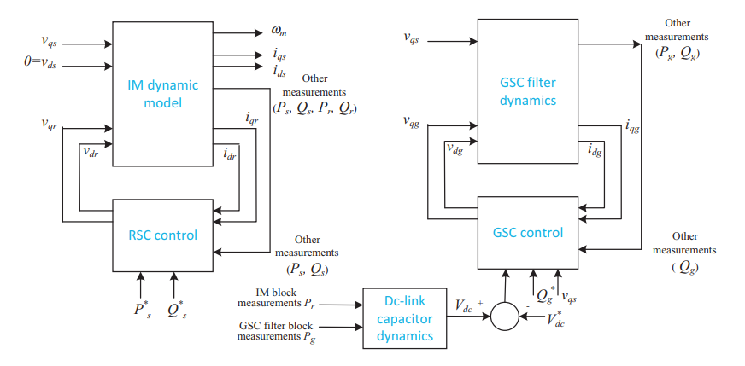

**Induction Machine dq0-axis Reference Frame Model**

A complex vector-based model was built to demonstrate the dynamics of an induction machine. All variables were in per unit. A complex vector was treated as two real variables with the q-axis leading the d-axis by 90°. Since the reference frame was aligned with the q-axis, the complex vector was expressed as:

Since zero-sequence currents do not introduce magnetic field, the zero-sequence circuits of stator and rotor were decoupled.

The d-, q- and 0-axis circuits for 3-phase Induction Machine are given below

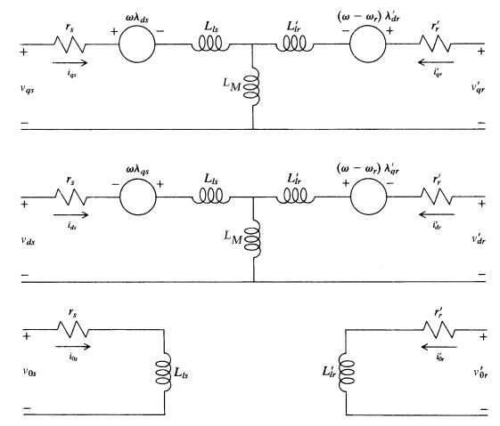

The corresponding Voltage Equations are

The Current Equations can be compactly represented as

The per unit Motion and Torque Equations are

**DFIG Rotor Side Converter Control**

A RSC is connected to the rotor circuit. The rotor currents should be regulated to avoid overcurrent in the RSC. In that sense, the inner current control for a RSC should be the rotor current control, while the outer control should be the real power (torque) and reactive power (ac voltage) control. The inner current control design and the output power control design are carried out in two separate steps. The dynamics of the current control is much faster than the power control. Separate control design was carried out for inner current control and outer power control. This aids the control of the entire export power or electromagnetic torque from DFIG.

1. RSC Outer Control

DFIG control relies on stator flux-oriented reference frame ( = 0 and = 0):

Since DFIG wind turbines are integrated to the grid and the grid voltage can be assumed as constant, the stator flux of the DFIG can be assumed as constant. The expression for electromagnetic torque simplifies to

The output real power and reactive power from stator circuit can be expressed as

The output real and reactive power from the stator circuit can be controlled via iqr and idr respectively. Hence, from the outer power control, rotor current references will be generated.

1. RSC Inner Control

It is through the inner current control that the rotor current commands will be followed by the rotor currents. Feedback control will be employed to realize the command tracking. The complex vector model of the rotor flux linkage is expressed as follows:

Substituting into the rotor voltage equations gives:

Hence the plant models are given by

Feedback controllers were designed based on these two first-order plant models to have desired bandwidths. After the feedback controllers, feedforward compensation was added back to generate the desired rotor voltages. This can also be done by adjusting iqr only.

For a short period of seconds, the wind speed can be assumed as constant. The rotor speed can also be considered as constant. If the rotor speed varies much slower than the power control, then we can assume that the slip s is constant and to regulate the entire power Pe, we just need to adjust iqr:

The overall RSC block diagram is given below.

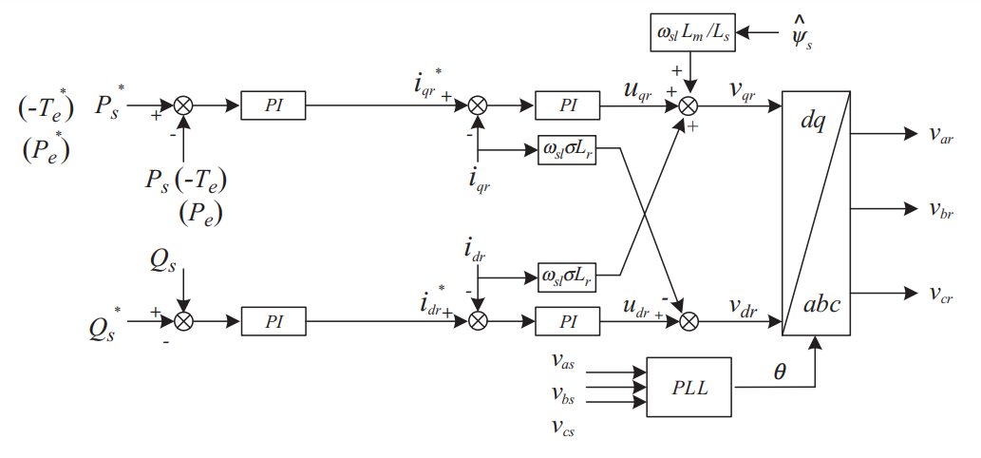

**DFIG Grid Side Converter Control**The GSC is connected to the grid through a filter and/or a transformer. The GSC is expected to regulate the AC side voltage/reactive power and to keep the DC-link capacitor voltage constant. With a constant DC-link voltage, the power through the RSC will be the same as that through the GSC. Therefore, this control objective realizes power balance of the converters.

1. GSC Outer Control

Let the q-axis of the reference frame align with the coupling point voltage vs and notate the converter output voltage as vg. The real power and reactive power from the GSC to the coupling point is expressed as

Therefore, if the coupling point voltage is kept constant (this should be the case for a grid-connected DFIG), real power and reactive power are linearly related to the q-axis and d-axis currents, respectively. We can again design decoupled real power and reactive power control.

The GSC control should take care of the DC-link voltage. The DC-link capacitor voltage can be expressed in terms of the power from the RSC and the power leaving the GSC to the grid. The convention of Pr follows the rotor current convention, where injection to the rotor circuit is positive. The convention of Pg follows the GSC current convention, where from the GSC to the grid is positive. Assuming that the DC voltage variation is small

Hence, the DC-link capacitor dynamics or the relationship between the RSC and the GSC is given by

The GSC Filter Dynamics were modeled as

1. GSC Inner Control

The converter is connected to the Point of Common Coupling through an inductor Lg. This inductor includes the effect of a filter and/or a transformer. The GSC output voltage, GSC current, and the coupling point voltage have the following relationship:

The feedback controller has the input from current measurement and generate the desired output. Through feedforward of cross coupling items, the desired converter voltages can be found.

The overall GSC block diagram is given below.

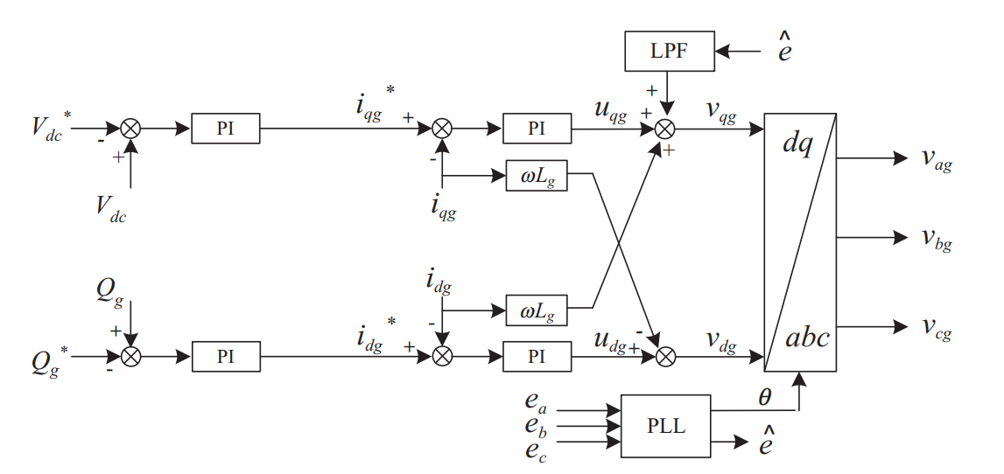

**DFIG Machine Constants**

1. Rated Line-Line Voltage
2. Number of Pole Pairs
3. Rated Stator Frequency
4. Stator Winding Resistance
5. Rotor Winding Resistance
6. Stator Leakage Reactance
7. Rotor Leakage Reactance
8. Magnetizing Reactance
9. Inertia Constant
10. Base Speed
11. Synchronous Speed

**Initial Conditions (t = 0-)**

In this case, the IG model in the synchronous reference frame was used, which was realized by setting the speed of the arbitrary reference frame w equal to ws. The dq-axis rotor voltages are provided by the RSC.

1. The reference frame is rotating at synchronous speed
2. Electrical Frequency
3. Rotor Speed
4. Stator Voltages
5. The rotor is not loaded
6. The initial DC Link Capacitor Voltage

The DC Link Capacitor Voltage reference changes from 1200 to 1220 V in the simulation

1. The initial references for active and reactive power

**Simulink Models**

The input variables of the model include the dq-axis stator voltages vds and vqs, rotor voltages vdr and vqr, the mechanical torque Tm. The output variables are dq-axis stator currents, ids and iqs, dq-axis rotor currents, idr and iqr, the electromagnetic torque Te, and the rotor speed wr of the generator.

1. DFIG System Simulation Diagram

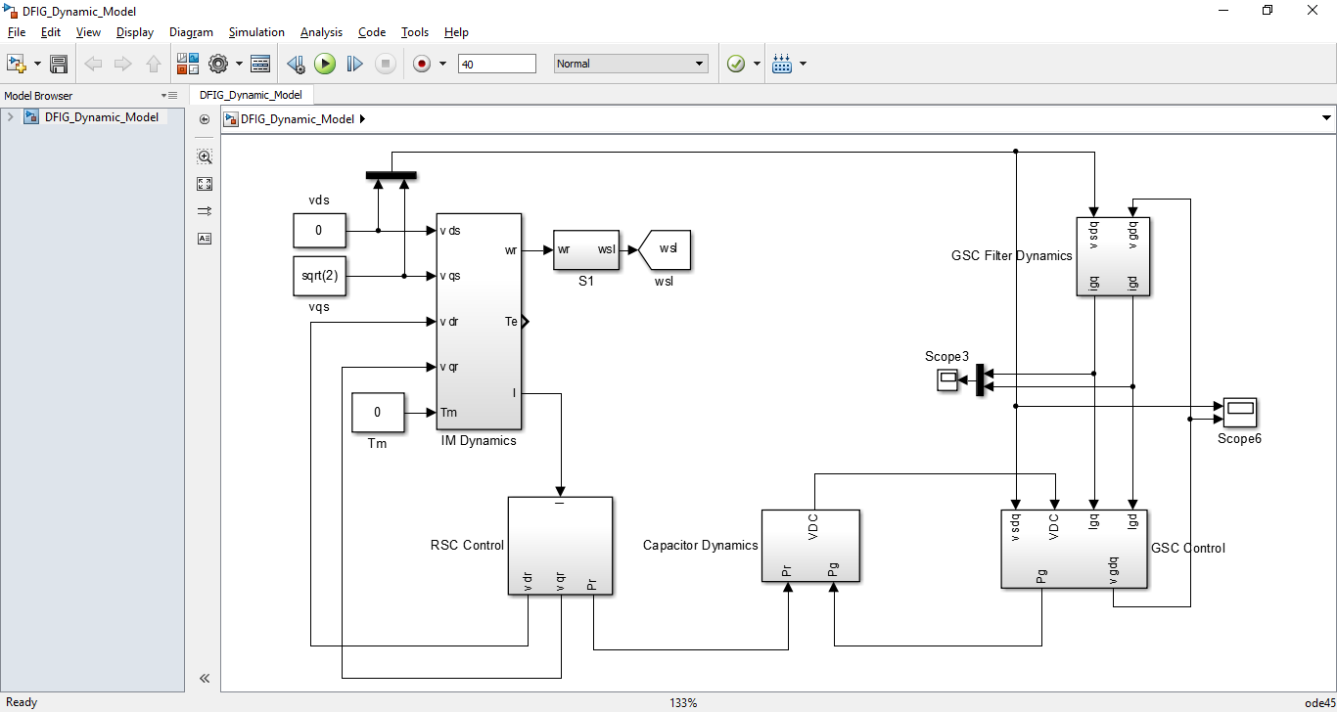

1. Induction Machine Block Diagram

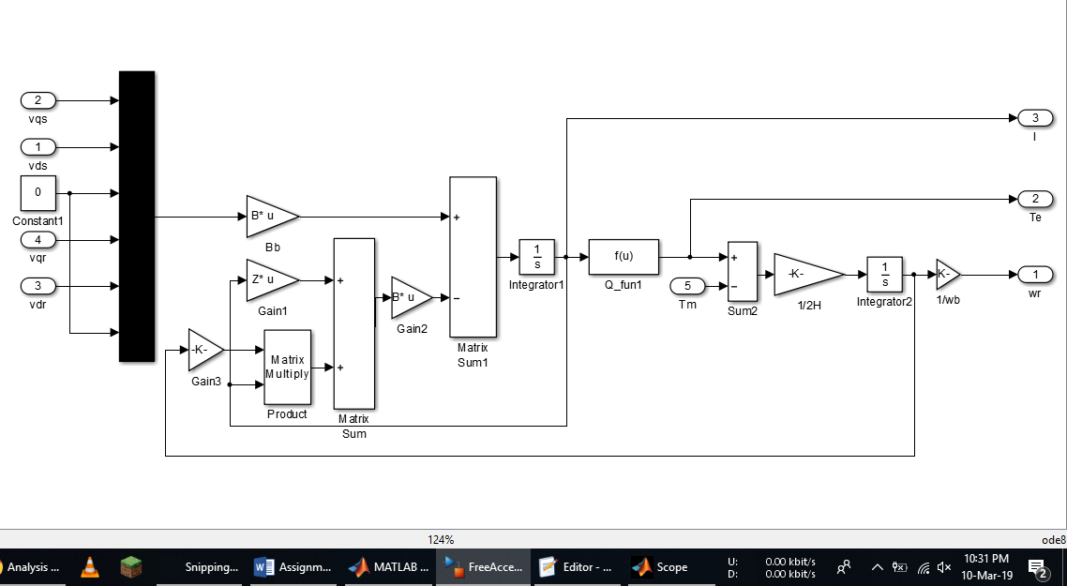

1. RSC Control Block Diagram

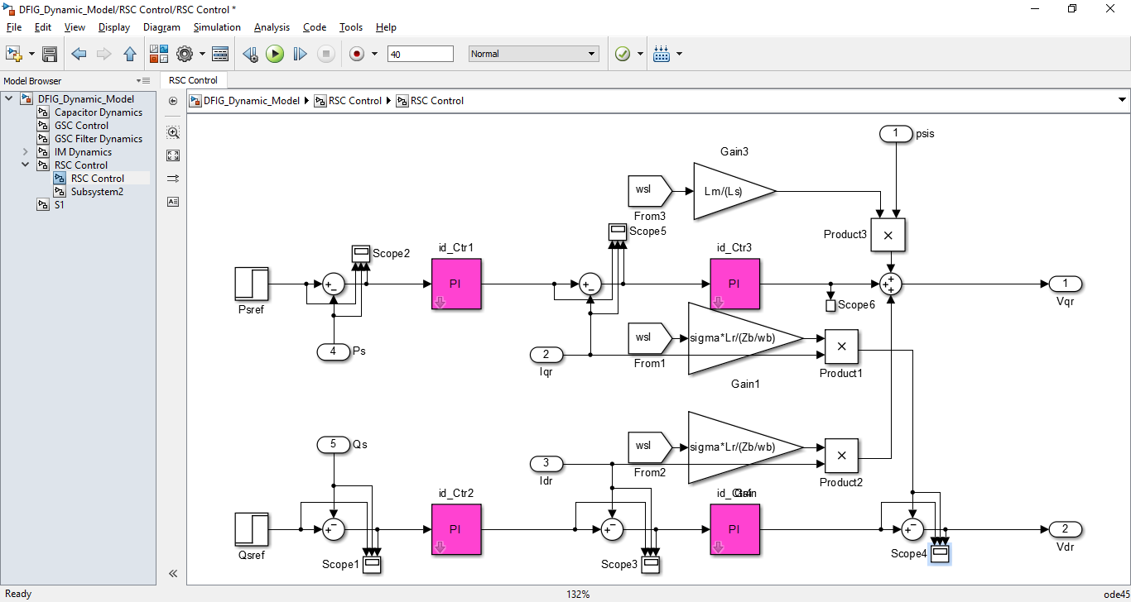

1. GSC Control Block Diagram

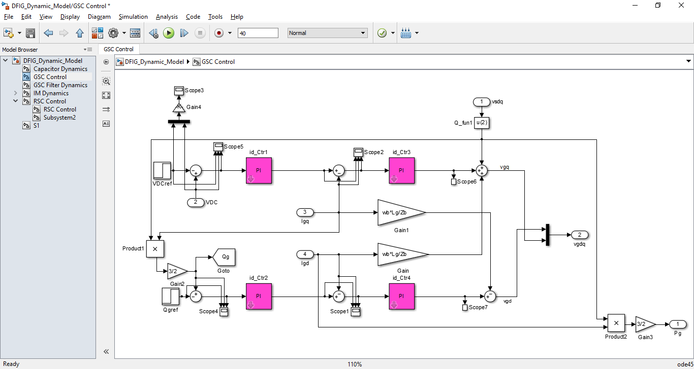

1. DC Link Capacitor Dynamics Block Diagram

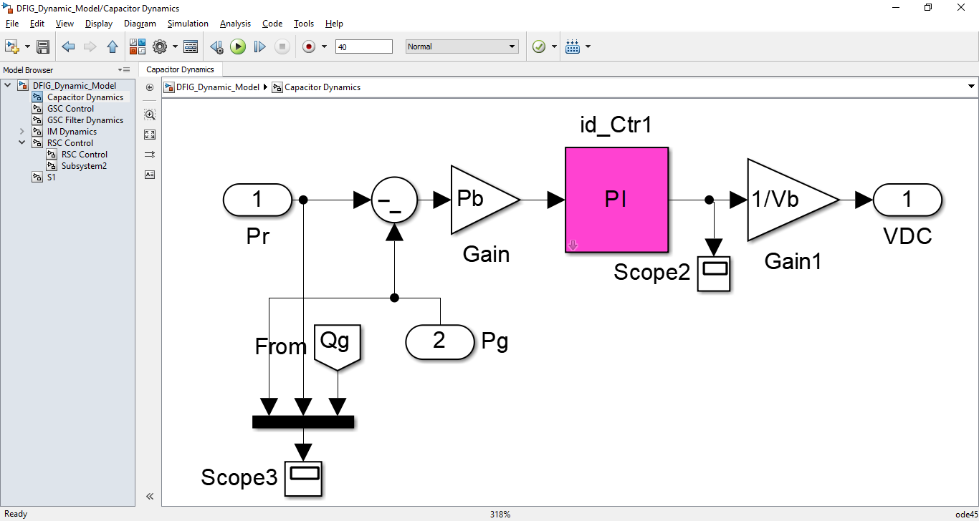

1. GSC Filter Dynamics Block Diagram

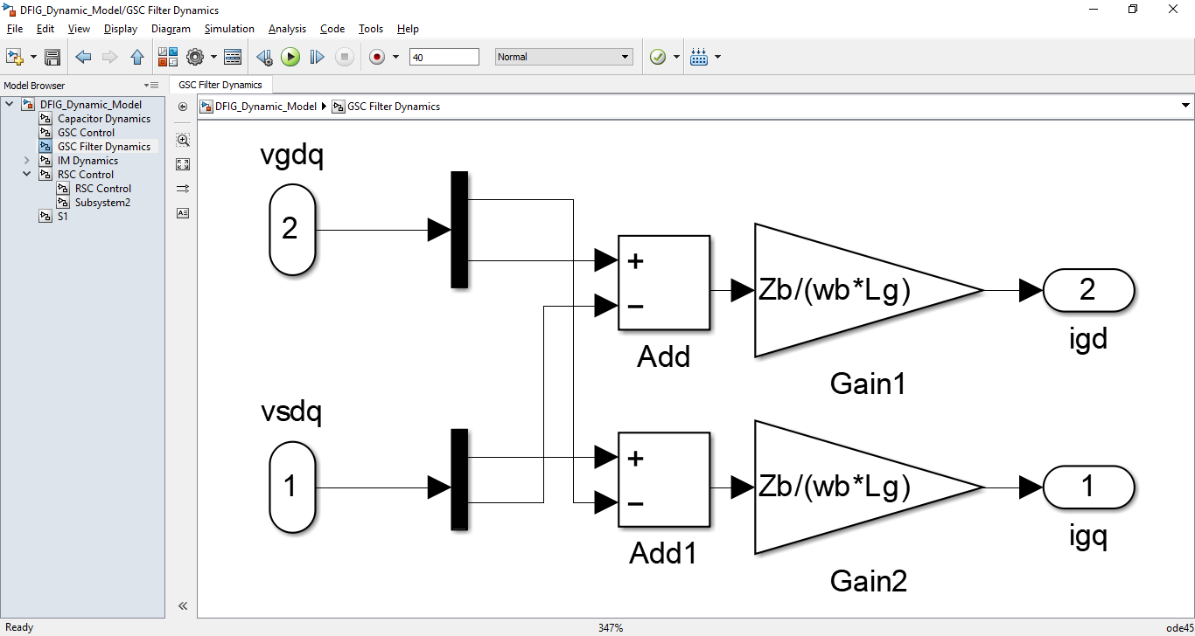

1. Initialization Commands MATLAB File

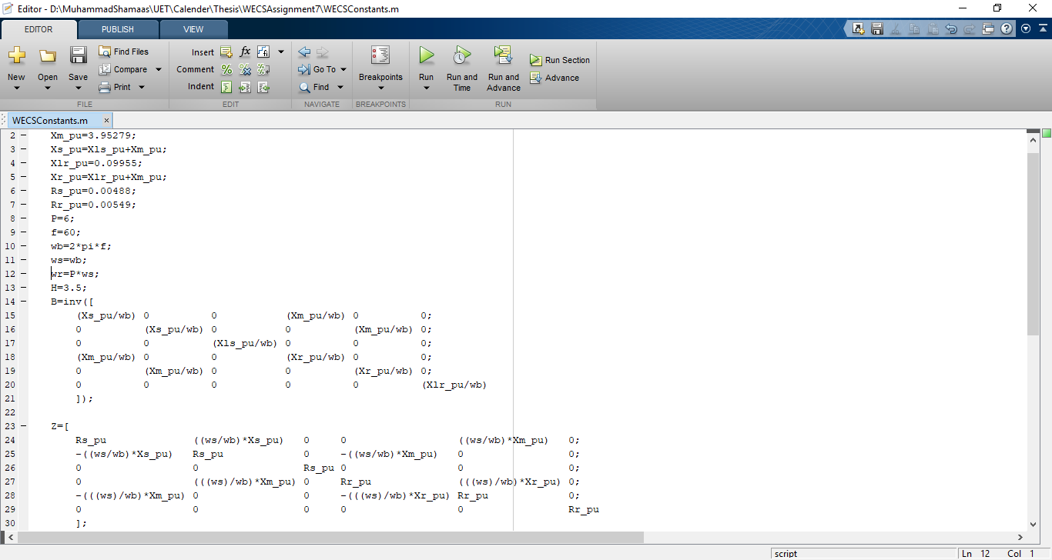

**Results**

1. Currents (iqg, idg)

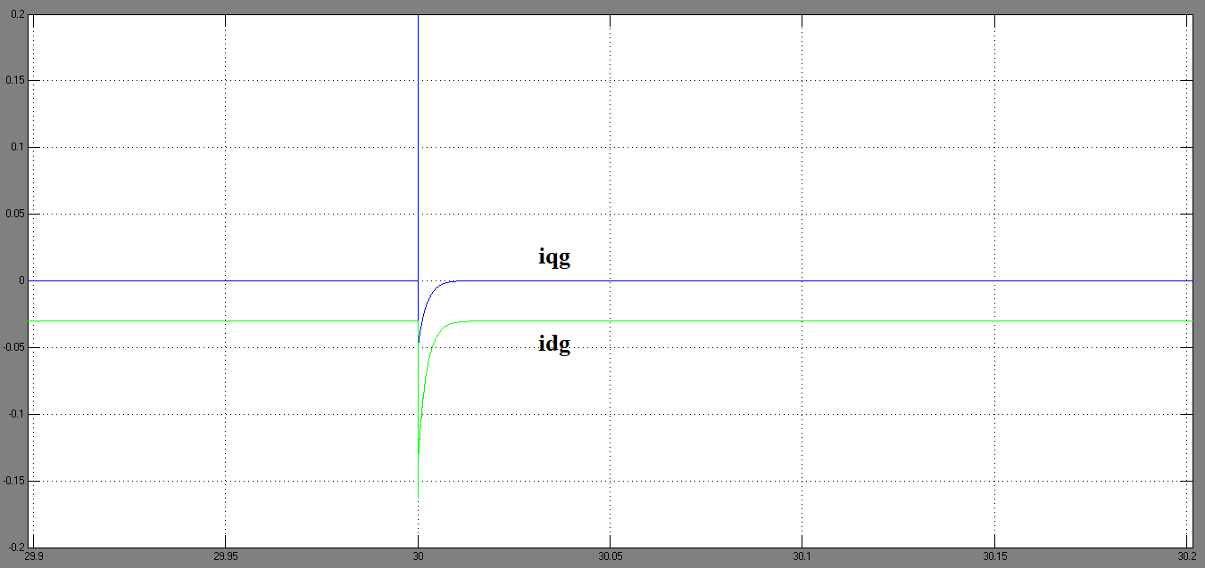

1. Pr, Qg and Pg

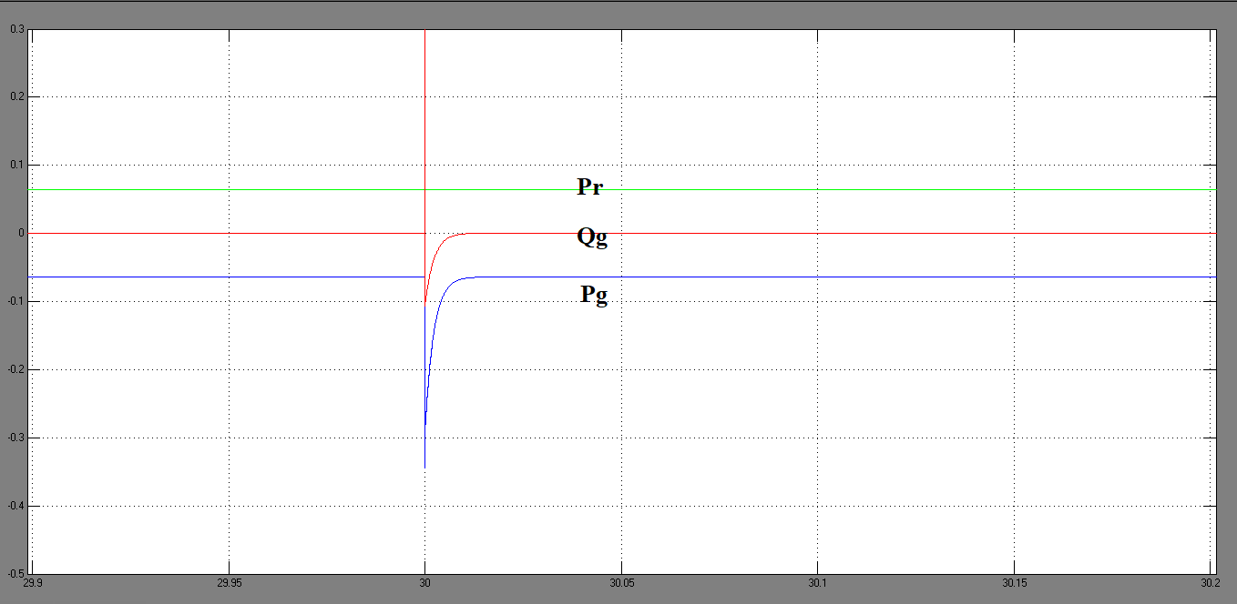

1. DC Link Capacitor Voltage and its Reference

